

CA PPM v14.3  
CA PPM v14.4  
CA PPM v15.1

Hierarchical Views r3.1  
Administration Guide

**Table of Contents**

1. Version History 3

2. Introduction 4

3. Deploying a new Hierarchical View 7

3.1. Create a new Hierarchical View Record 7

3.2. Create a CA PPM Studio Query 12

3.3. Create a new CA PPM Studio HTML Portlet 14

3.4. Place your new portlet on a Page 15

4. Known Issues and Limitations 16

# Version History

|  |  |  |  |
| --- | --- | --- | --- |
| Author | Date | Version | Comments |
| Alexandre Assis | 09/Jan/2015 | 1.0 | Initial Release |
| Alexandre Assis | 25/Mar/2015 | 2.0 | Second Release, added Word Trees and Sankey Diagrams |
| Alexandre Assis | 01/Oct/2015 | 2.2 | New syntax for loading Google Charts Libraries  New Google Charts version  Ability to Print Diagrams  Corrected GUnload() Unlnown function error  Enhanced page-independent Portlet Template |
| Alexandre Assis | 08/Dec/2015 | 3.0 | CA PPM SaaS compatibility by replacing a server JSP with an html component in the Knowledge Store  Hard Codes eliminated by adding new Enhanced Options to the Hierarchical Views object |
| Alexandre Assis | 28/Dec/2016 | 3.1 | Replacing the File in the Knowledge Store with an attachment attribute in a new Object called “HTML File” due to the change introduced in [CLRT-81099](http://jira/browse/CLRT-81099) that disabled the use of html files in the Knowledge Store for HTML Portlets. |

# Introduction

The Hierarchical Views package allows you to create custom hierarchical views and deploy them on CA PPM Pages using HTML Portlets. On this Version four types of Hierarchical Views are supported: the Tree Map (also known as Tree Heat Map), the Organizational Chart, the Word Tree and the Sankey Diagram.

See ***examples*** below.

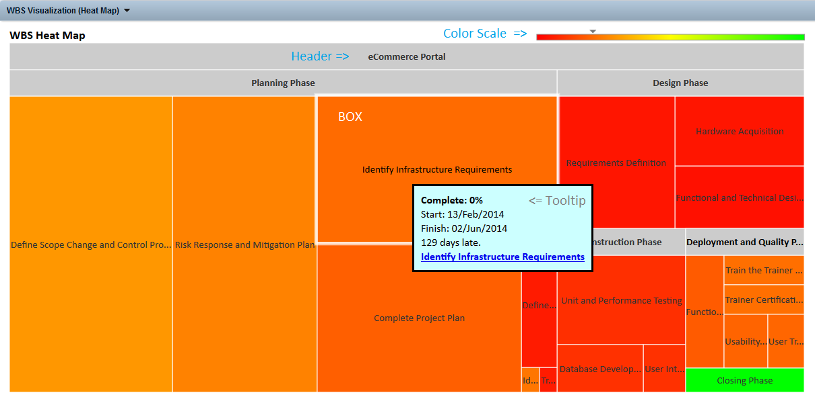

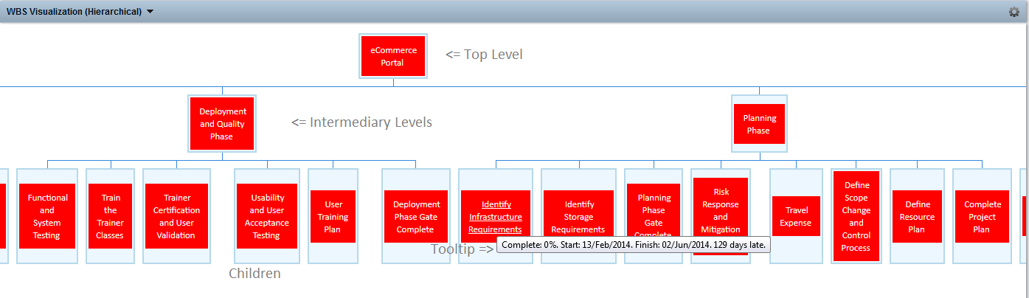

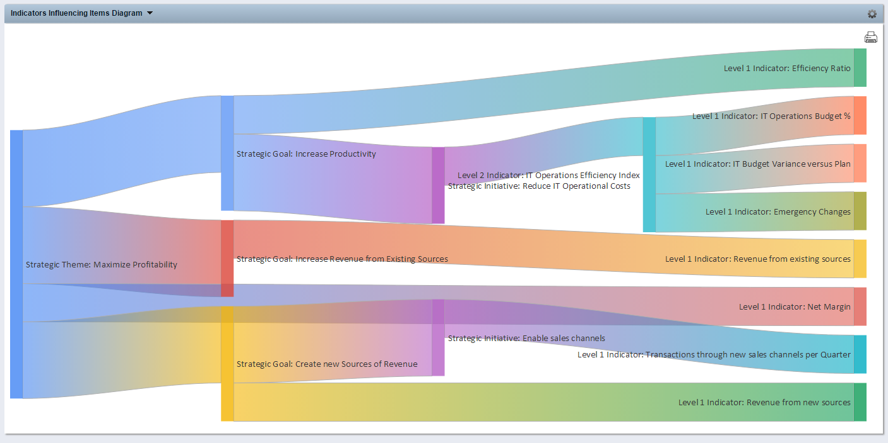

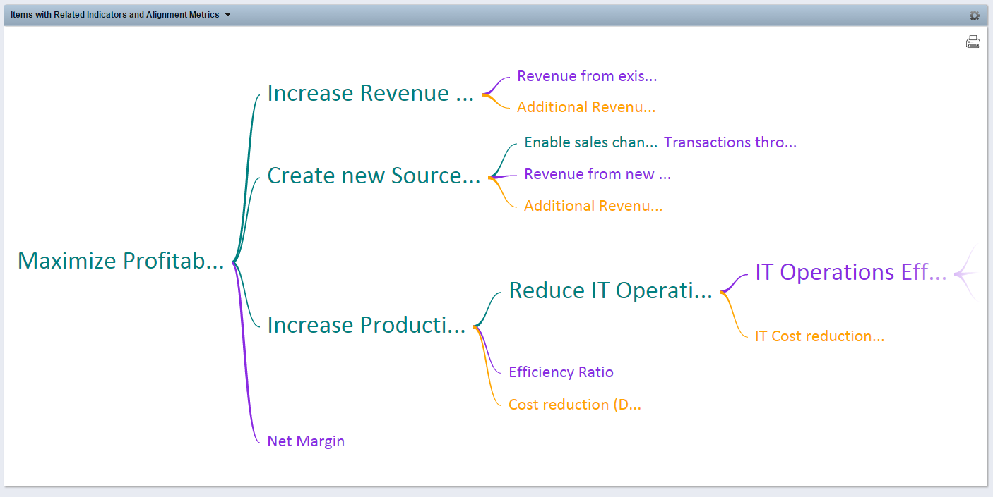

# Deploying a new Hierarchical View

To create a new Hierarchical View, follow these steps.

## Create a new Hierarchical View Record

Login: Admin

Start in Home -> Custom Objects -> Hierarchical View List

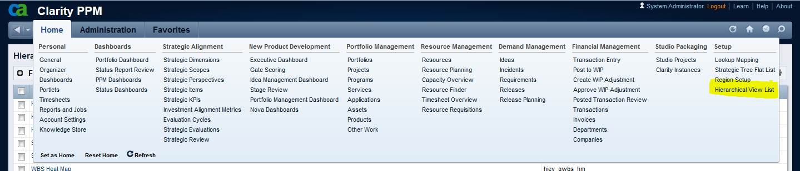

|  |  |
| --- | --- |
|  | Click New Hierarchical View |
|  | Enter a new Name, a new ID and choose the Hierarchy Type.  **Standard Naming for the ID:**  **hiev_**<package>**_XXXXXX**_<type>  hiev: this is the Hierarchical Views package identifier  package: is the code used to identify your custom package (i.e. **strat** for Strategic Planning, **gwbs** for Graphical WBS, and so forth)  XXXXXX: is the portlet specific identifier  (i.e. what is the view you are creating)  type: use **hm** for Heat Maps, **org** for Org Charts, **wt** for Word Trees and **sd** for Sankey Diagrams    Click **SAVE** |
|  | On the Properties Page, enter the **Required Information.**  **You need to inform the ID of the CA PPM Studio Query you will use to populate your view.**  **More information on how to build your query will be available later this chapter.**  Click the appropriate TAB depending on the type of Chart you are creating. |
|  | **Heat Map Options**  On the **Basic** section you will find the most frequently changed properties to guide the behavior of a Tree Heat Map.  On the **Advanced** section you will find additional Formatting options.  To get more information on each option visit [Google Charts Tree Map](https://developers.google.com/chart/interactive/docs/gallery/treemap).    The most important:  Portlet Width and Portlet Height: allow you to create Views adequate to your specific needs  Min, Mid, Max Color: Min Color refers to the lowest values, Max Color refers to the highest values. Mid Color is the one in the middle. These three colors will result in a color scale.  Tooltip Width and Color: refer to the tooltip when you hover over the Chart.  Max Depth: maximum levels you want on the view  Select “Drill to New Page” to open a new Browser Tab when Drilling Down from your chart.  All attributes have standard values that can later on be adjusted if required.  Click **SAVE AND RETURN** |
|  | **Org Chart Options**  Choose the Chart Node Size (small, medium or large).  Select “Drill to New Page” to open a new Browser Tab when Drilling Down from your chart.  Choose the Font Size and Family.  All attributes have standard values that can later on be adjusted if required  Click **SAVE AND RETURN** |
|  | **Word Tree Options**  Portlet Width and Portlet Height: allow you to create Views adequate to your specific needs  Choose the Font Family and Font Size. Font Size refers to the Maximum font size. Actual Font Size will vary automatically according to the data.  Choose the Word Tree Type –  Effect->Cause or Suffix trees draw from right to left representing information that is aggregated from the detailed left nodes to the right main node.  Cause -> Effect or Prefix trees draw from left to right representing information that is aggregated from the detailed right nodes to the left main node.  All attributes have standard values that can later on be adjusted if required  Click **SAVE AND RETURN** |
|  | **Sankey Diagram Options**  On the **Basic** section you will find the most frequently changed properties to guide the behavior of a Sankey Diagram.  Portlet Width and Portlet Height: allow you to create Views adequate to your specific needs  Node Width will set the size of the nodes.  Set the desired Font Family, Size and Color.  On the **Advanced** section you will find additional Formatting and Behavior options.  To get more information on each option visit [Google Charts Sankey](https://developers.google.com/chart/interactive/docs/gallery/sankey) Diagram.    Click **SAVE AND RETURN** |

## Create a CA PPM Studio Query

You need to create a new CA PPM Studio Query using NSQL to retrieve the data you need for your Hierarchical view.

Below you will find a template query with the explanation of each attribute:

Select

@SELECT:DIM:USER_DEF:IMPLIED:NODE:X.NodeID:NodeId@

,@SELECT:DIM_PROP:USER_DEF:IMPLIED:NODE:X.NodeName:NodeName@

,@SELECT:DIM_PROP:USER_DEF:IMPLIED:NODE:X.NodeParentName:NodeParentName@

,@SELECT:DIM_PROP:USER_DEF:IMPLIED:NODE:X.NodeParentID:NodeParentID@

,@SELECT:DIM_PROP:USER_DEF:IMPLIED:NODE:X.NodeLevel:NodeLevel@

,@SELECT:DIM_PROP:USER_DEF:IMPLIED:NODE:X.NodeLevel:NodeSortOrder@

,@SELECT:DIM_PROP:USER_DEF:IMPLIED:NODE:X.NodeSize:NodeSize@

,@SELECT:DIM_PROP:USER_DEF:IMPLIED:NODE:X.NodeColor:NodeColor@

,@SELECT:DIM_PROP:USER_DEF:IMPLIED:NODE:X.NodeColorName:NodeColorName@

,@SELECT:DIM_PROP:USER_DEF:IMPLIED:NODE:X.NodeFontColorName:NodeFontColorName@

,@SELECT:DIM_PROP:USER_DEF:IMPLIED:NODE:X.NodeLinkURL:NodeLinkURL@

,@SELECT:DIM_PROP:USER_DEF:IMPLIED:NODE:X.NodeAdditionalInfo:NodeAdditionalInfo@

,@SELECT:DIM_PROP:USER_DEF:IMPLIED:NODE:X.NodeAdditionalInfoHTML:NodeAdditionalInfoHTML@

from (

[YOUR QUERY HERE]

) X

WHERE @FILTER@

You need to replace “[Your Query Here]” with the appropriate SQL text to retrieve data for your Hierarchical View.

Typically you will use a query for each level, with a “UNION” statement between them. All those attributes should be present even when they have no values. In that case replace them with 0 or ‘’ depending on the attribute type.

In the following table you will find information specific to each attribute and each chart type.

|  |  |  |  |  |  |  |
| --- | --- | --- | --- | --- | --- | --- |
| Attribute | Description | When is it required | | | | Additional Information |
|  |  | Tree Maps | Org Chart | Word Tree | Sankey Diagram |  |
| NodeId | The Internal ID for the information you are retrieving. | Yes | Yes | Yes | Yes |  |
| NodeName | The Name that describes the information you are retrieving | Yes | Yes | Yes | Yes |  |
| NodeParentId | The Internal ID identifying the Parent of the Node | Yes | Yes | Yes | Yes |  |
| NodeParentName | The Name that describes the Parent of the Node | Yes | Yes | Yes | Yes |  |
| NodeLevel | Indicates the Level of this information in regards to the Hierarchy | Yes | Yes | Yes | Yes |  |
| NodeSortOrder | Most Google Charts expect data to be in certain order (Parents should always appear before their children) | Yes | Yes | Yes | Yes | Normally, sorting by level will do the trick. You may need to create specific expressions in some cases to obtain the proper order. |
| NodeSize | Should be mapped to an attribute representing the relative size of the Nodes in the **Tree Map**, the Words in the **Word Tree** and the weight of the Links in the **Sankey Diagram**. | Yes | No | Yes | Yes | This is likely to be an importance metric such as Duration, Effort, Weight, Level, etc |
| NodeColor | Should be mapped to a numeric attribute used to determine the color of the node in Tree Maps **only**. | Yes | No | No | No | This is likely to be a numeric attribute indicating a performance index or state, such as Schedule %, Risk Score, Status, etc |
| NodeColorName | Should be mapped to a string attribute containing an HTML, HEX or RGB color for each node.  . | No | Yes | Yes | No | This is likely to be a Case/When/End statement mapping a numeric value that indicates a performance index or state, such as Schedule %, Risk Score, Status, etc, to a color |
| NodeFontColorName | Should be mapped depending on the NodeColorName color to avoid unreadable charts with combinations such as “white font over yellow box” or “black font over dark blue box”. | No | Yes | No | No | This is likely to be a Case/When/End statement using the same information from NodeColorName to select the appropriate font Color |
| NodeLinkURL | Should be mapped to a string containing the CA PPM Link URL so you can link your Chart to CA PPM Object Instances | Yes | Yes | No | No | Should have the format of a CA PPM URL starting in “/niku” such as:  /niku/nu#action:xxxxx&id=yyyy |
| NodeAdditionalInfo | Should be mapped to any attributes containing additional info you want to show on Org Charts as a Tooltip. | No | Yes | No | No | Unformatted text. |
| NodeAdditionalInfoHTML | Should be mapped to any attributes containing additional info you want to show on Tree Heat Maps as a Tooltip. | Yes | No | No | No | Formatted HTML text. |

## Create a new CA PPM Studio HTML Portlet

Create a new HTML Portlet to use your newly defined View.

To easily identify your Hierarchical View Portlets, consider using the following naming standard for the portlet ID:

<package>_hiev_XXXXXX_<type>

package: identifies your customization initials

hiev: a fixed-string that identifies this as a hierarchical view

XXXXXX: Portlet Identifier that tells us what this is about (optional)

type: is the Hierarchy Type: **hm** (Heat Map), **org** (Org Chart), **wt** (Word Tree), **sd** (Sankey Diagram)

Example: we have created a new portlet to show a graphical view of a wbs using the org chart. The Portlet id is **gwbs_hiev_org**

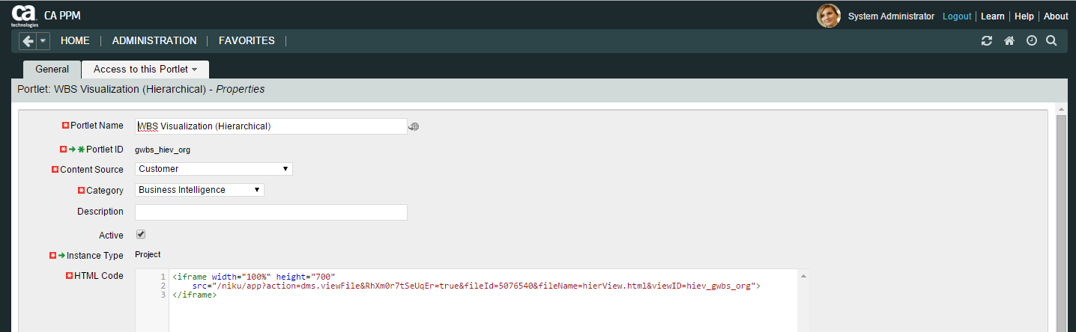

This is the HTML code you need to include in your portlet:

<iframe width="100%" height="700"

src="/niku/app?action=union.viewODFFile&**fileId=5101215**&**versionId=5101216**&**odf_pk=5000000**&objectType=hiev_html_file&RhXm0r7tSeUqEr=true&**viewID=hiev_gwbs_hm**">

</iframe>

Please notice:

The **viewId** parameter refers to the Hierarchical View Object Instance you created before (please refer to “Create a new Hierarchical View Record”).

The **fileId, versionId and odf_pk** parameters refers to the hierView.html file you have in your HTML File object instance. To find out the appropriate value, follow these steps:

* Go to Home, Setup, HTML File
* Click on the hierView.html instance.
* Right-click the HTML File attribute Open Icon and select “Copy link address”
* Paste it somewhere to verify the correct fileId, version Id and odf_pk to use in your HTML portlet.

## Place your new portlet on a Page

Hierarchical Views are normally Instance-Specific, so they would be placed on an Object’s “Page Layout”. You can create a new Tab on an existing page or create a new Page to host your new HTML Portlet.

Open your Object Page Layout in the desired Tab.

To easily identify your Hierarchical View Pages, consider using the following naming standard for the page ID:

<package>_hiev_XXXXXX

package: identifies your customization initials

hiev: a fixed-string that identifies this as a hierarchical view

XXXXXX: Page Identifier that tells us what this is about

Example: On the **PMO-Project Status** we have created a new Tab called “**WBS View**” to deploy our new WBS Views, with the id

**gwbs_hiev_wbs**

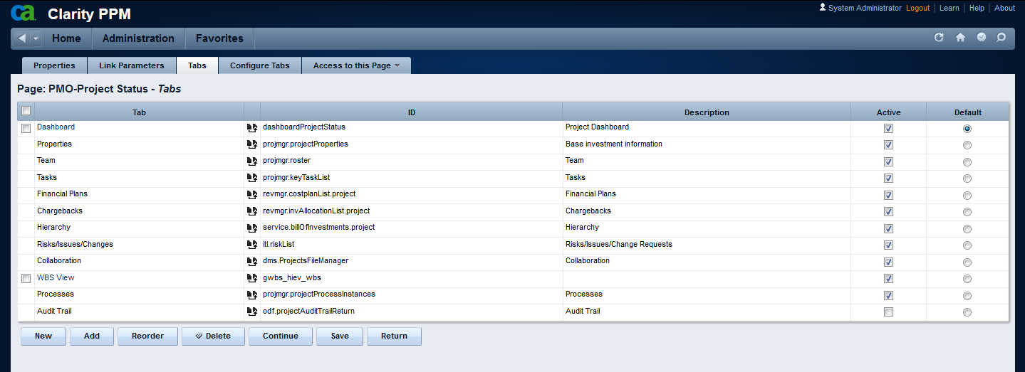

Add your Hierarchical Views Portlets to this tab. Ideally, set one of the Portlets as Maximized.

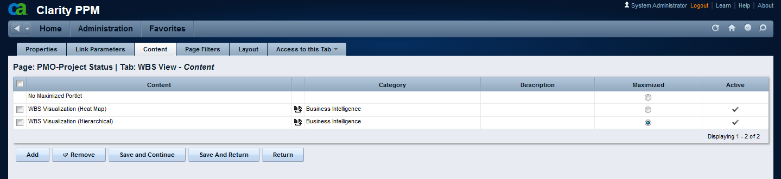

# Known Issues and Limitations

This package uses Google Charts. Therefore, you will need Internet access from your CA PPM server for them to work properly.